

Lab 8: Introduction to Ubidots

Instructor: Rameez Ashraf

  - SMRTTECH 3CC3
  - Cloud Computing and Internet of Things
  - B. Tech - SMRTTECH

Submitted by: Nicolas Jao - 400450151
Partner (s): Jacob Kwan - 400453713
Lab Section: L04
Date of lab: October 27, 2025

Abstract
In this experiment, an ultrasonic distance sensor and a status LED were integrated with an Arduino microcontroller and connected to a PC running LabVIEW, with cloud connectivity through Ubidots. In the first phase, the Arduino collected real-time distance data from the ultrasonic sensor and transmitted both the sensor readings and LED status to the Ubidots cloud platform via serial communication and LabVIEW. The data was visualized on a custom Ubidots dashboard, allowing remote monitoring of system status. In the second phase, control was reversed: the LED was actuated directly from the Ubidots dashboard, with commands sent from the cloud to LabVIEW and then to the Arduino, demonstrating bidirectional communication between the embedded system and cloud interface. The experiment highlights the integration of IoT data acquisition and remote-control using LabVIEW and Ubidots, illustrating how local sensing systems can be extended to cloud-based monitoring and actuation.

Results & Discussions
- Block diagram:
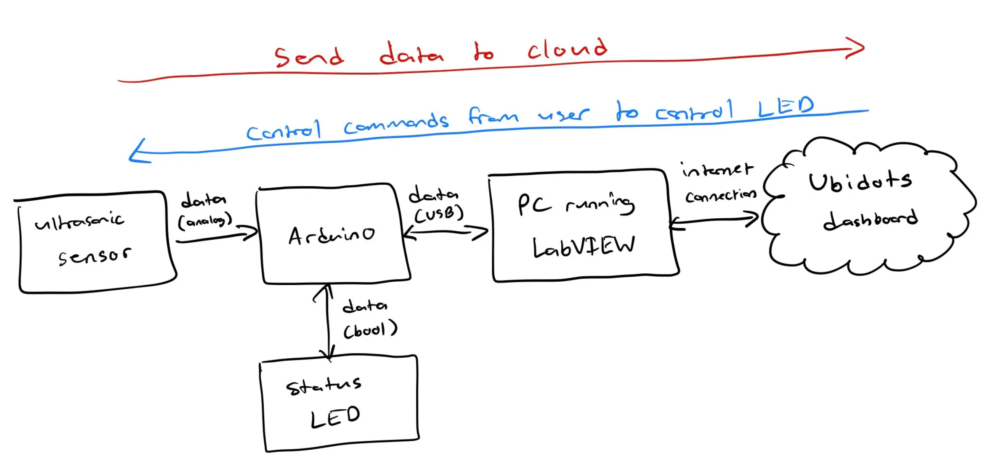
The sensors are only connected directly to the Arduino, so data can only flow from the Arduino to them or from them to the Arduino. Therefore, any commands from the LabVIEW HMI or the Ubidots dashboard must send the data to the Arduino first, which controls the sensor and LED.

- An ultrasonic sensor measures distance by sending out a sound wave at a specific frequency and timing how long it takes for the echo to return. When in operation, it is always sensing for that specific frequency and when it gets it back, it does calculations to determine the distance with the time it records for the sound to get back. The TRIG pin tells the sensor to send a short ultrasonic pulse, when activated. The ECHO pin outputs a signal whose length shows how long the echo takes to return.
- LabVIEW provides a graphical interface for data visualization and control. You can easily display real-time sensor readings on charts and indicators. You can send data
- (See Lab 7.vi file submission)
- N/A

Conclusion
In this experiment, an Arduino-based system integrating an ultrasonic sensor and a status LED was successfully connected to a PC through LabVIEW and linked to the Ubidots cloud platform. In the first mode, the Arduino continuously transmitted real-time distance readings and LED status data to LabVIEW, which then uploaded them to Ubidots for visualization on an online dashboard. This demonstrated effective one-way data flow from the physical system to the cloud. In the second mode, control was reversed. Commands sent from Ubidots were received through LabVIEW and executed by the Arduino to toggle the LED, showcasing two-way communication between the embedded hardware and the cloud interface. The experiment effectively demonstrated how LabVIEW can serve as a middleware layer for Internet of Things (IoT) applications, enabling both remote monitoring and direct actuation of hardware systems through cloud-based interfaces.

